Note: This document is “view only”. Please create a copy of this document and save it to your drive.

**SOP- Setting Up Clients in Google Analytics - Systems Vault**

**PREREQUISITES**

[SOP MASTER- Client Onboarding- Systems Vault](https://docs.google.com/document/d/1h15rYHmTzGFdfzso_DxqyYtqkFcpNlM8DWo4YLwYBn4/edit?usp=sharing)

<https://analytics.google.com>

[SN Master: Client Details](https://docs.google.com/spreadsheets/d/1jHG9MEvCmCceeMhdQoOiuUFtzoz0OX240_Fw3Km_i98/edit?usp=sharing)

[Configure Analytics to display Demographics and Interests data](https://support.google.com/analytics/answer/2799357?hl=en&utm_id=ad&visit_id=1-636214677437186115-2307205326&rd=1#configure)

**PURPOSE**

To ensure ease of use when monitoring client’s analytics on a monthly basis.

**POLICY**

Client analytics accounts are shared with [team@sarahnoked.com](mailto:team@sarahnoked.com) and their designated OBM

If the client has Google Analytics set up already, they will share with us.

For clients without Google Analytics or new websites, we will set up their GA

All clients should have the Sarah Noked Master Dashboard on their Google Analytics for EACH of their websites  
  
**PARTY**

Online Business Manager

**PROPERTY**

Online Business Manager

**PROCESS**

Part 1: Start a new Google Analytics account or adding a new website to an existing account (skip this if not needed)

Part 2: Import dashboards

**PROCEDURE**

**Part 1: Start a new Google Analytics account or adding a new website to an existing account**

1. Sign in to team@sarahnoked.com
2. Go to<http://www.google.com/analytics/> and click on “Access Google Analytics”.
3. If the client does not yet have a Google Analytics account, click on ‘Admin’ > ‘Account’ > in the menu ‘Create a new account’.

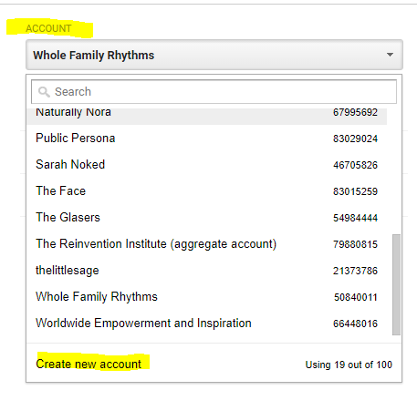

1. Create an account name, website name and put in the client’s website url (without the http://www). Unless otherwise specified this field is the **Client’s Name- Business Name.**

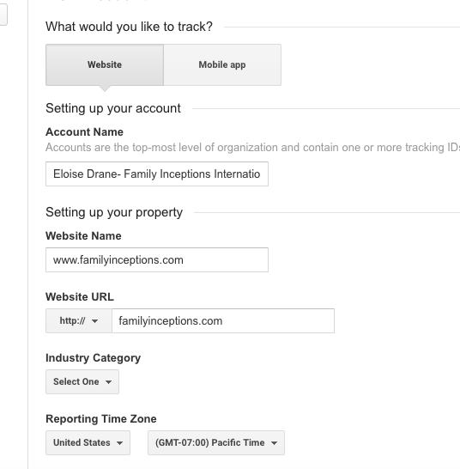

1. Press ‘Create Account’
2. Copy the website tracking code, paste it in a ‘text edit’/plain text file and assign to our developer to add this to the header code of the client’s website.
3. PROBE: Once the developer replies that the client’s website has started tracking, enter Google Analytics > Client > All Web Site Data > Reporting > Audience > Overview
   1. Make sure that there are up to date metrics being tracked.
   2. Share access to the client’s preferred email address

**Part 2: Import Dashboards**

1. For each client website, click on “Dashboards” and then “+ New Dashboard”.
2. Select Screen Shot 2015-08-25 at 11.00.57 PM.png
3. In the search bar enter the desired dashboard’s name. The dashboards we work with are:
   1. **Sarah Noked Master Dashboard-** unless specified differently, this is the only dashboard we will be working with.
4. Select import
5. Make sure that you will be checking “All Web Site Data” for the correct client.
6. 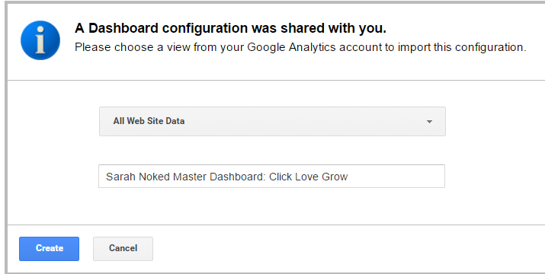
7. Update the title of the dashboard so it includes the correct website under this format: Sarah Noked Master Dashboard: Website Name
8. Create

**Created by:**

**Department:** Delivery

**Date:**

**Revised:**

**Revised by:**